Other On-Call Numbers
Security:
2444 (HQ): 602-864-4464 2525 (Townley) 602-864-2180 2475 (TDC) 602-864-2087

DXC On-call:
Primary 602-723-6418 – someone name Tanya
Secondary 602-723-6394 - disconnected
EBT: 480-415-6357
MetaVance/SI-5 Missing Files: 602-723-6394
TPS Cycle / Tertiary: 602-757-0136 (regarding VAT file/ TPS /txndata file)
Manager on-call: 602-318-0775
Kelly Royer 1-816-529-8907 – If needed
Pat Daley 602-740-1014 – If needed

PlanConnexion On-call (Chicago, IL) (related: Association, Blue2, SI5):
Support 312-297-5500/6116 or 800-789-0051.
1 – Association technical support.
2 – Plan support (PX = ITS Files)
3 – Blue distinction center support

SI5:
-Any issues with SI5 contact EMFT on-call before server services.
-Any issues related to a file not going through contact
Andrea Browning at 602-625-9129
Hung Nguyen: 623-252-2456
-Any system issues or bigger issues with SI5 systems contact Bill Eblin 480-594-0888

Connecture (Insurix) 24-hour Support Line:
Support 866-878-9948 - disconnected
Send e-mail to bcbsazsupport@connecture.com

BES Operations (Pontiac, MI):
24/7 866-214-0108 press 1, 1, 1

Peoplesoft On-call (related to timecard):
Primary Support 877-741-3330
Press 2 for Velocity customer service
Secondary Support 704-315-6197

-Explain issue (include screen shot) and send to servicedesk@velocitycloud.com, finsupp@azblue.com CC: ops
-Velocity will take your information; they will email you back with their incident number
-Created incident (include Velocity incident #) and assign it to Finance Support (Laura Walker).

Alere on-call: 1-877-719-9004 After Hours 1-770-767-4559.

Iron Mountain: 1-888-365-4766
User information needed when calling- Account number (DP####) and Authorization number (6 digit number)
Customer Care Email: request@ironmountain.com
Technical Support Phone: (800) 934‐3453
Technical Support Email: imosdpsupport@ironmountain.com

Convergys – Orlando (solarwinds alerts regarding switch - INC0069889)

POC is Edward Laskowski (407-771-6781 and ed.laskowski@convergys.com) for any routine day-to-day items such as any scheduled IT changes or any other non-emergency items.

For any immediate or emergency issues the Convergys Service Desk (CSD) is operational 24x7x365 and should be the point of contact. The CSD agents are non-technical but they can open a trouble ticket for your issue and begin the resolution process. If the issue is an emergency I would advise that when speaking to the CSD agent you request to be transferred to Situation Management (SitMan). SitMan is also a 24x7x365 shop and SitMan staff are technical folks and can page out the appropriate on-call technicians to support resolution of an issue. The CSD phone number is 888-578-3333 / Convergys Orlando Operations. (407) 771-8539.

SXC/Catamaran/Optum password reset. (Optum RX in Florida)

G:\OPS\Documentation\1_Operations Monitoring\Optum (SXC-Catamaran)\Self Service Password Reset - Clients.pdf

Here is another number they have listed for us to use 877-422-7718

If someone calls for an SXC/Catamaran/Optum password reset you’ll need to contact the SXC helpdesk at 1-800-316-5148 option 5, then option 2. Secondary number is 1-855-312-6102 (make sure you have user’s profile id) and let them know you are calling from BCBSAZ and need to have an SXC password reset. They will need the user ID / profile name and will provide you with a random temporary 8 character all lower case password to provide to the end user. Tell the help desk techs that the system our users are logging into is “RXClaim” and the environment is “CCTA”. This is an AS400 application. You can also ask them to look up the user name in Active Directory.
Client Service Manager: Mike Banks (630) 453-3476

https://asp.optum.com/

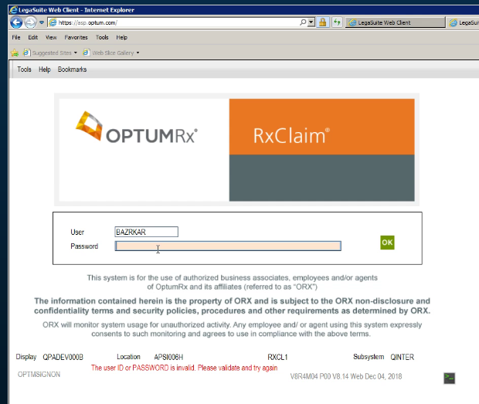

Service Desk
Liz Baldwin / Autumn Oberlander
Liz Baldwin desk: (602) 864-7865 cell: (602) 721-2404 for all urgent matters. For all non-urgent matters create a SN ticket and assign to service desk and send Kim an email with the incident number included.

Nurse on-call
-Phone rotation (need pin number)
-ADOA line. Line transfer over after 6:00pm to the voice mail mailbox (citrix hub)
-make sure they using citrix hub not the old secure mail.
-Need reset pin – Nurse department needs to reach out to their Manager
-Actually voice mail issue – telecom
-Actually issue with shared mailbox– eric Royce

McKessen

Contact McKessen personnel at pnsapps@changehealthcare.com for any after hours issues.

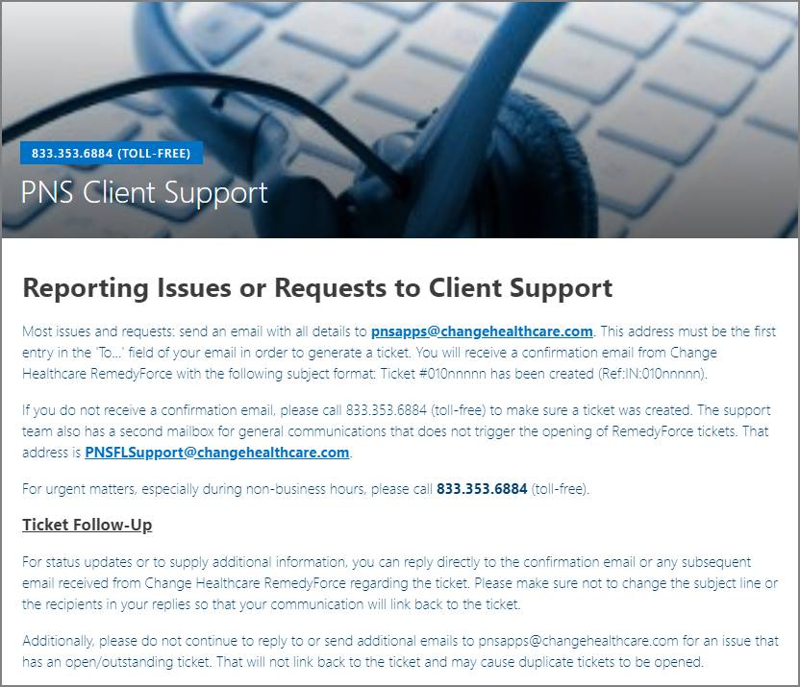

McKessen (cont.)

Use the on-call phone above for McKesson. The below numbers are old contact info.

- John MacKinnon, First
  - PH: John MacKinnon: (850) 543.3491, (850) 508-5876, (850) 208.3407
- Earl Page, Second
  - PH: Earl Page: (850) 417.8907
- Kelly Holland, Third
  - PH: Kelly Holland: (850) 208.3371

